**Market Research App Instructions**

**Step 1: Data Download from USASpending.gov**

Navigate to USASpending.gov. On the left-hand side of the homepage, you’ll find a panel with various filter options. Using the information from the request form, apply the following filters:

* Time Period: Select the most recent fiscal year or the two most recent fiscal years, depending on how far you are in the current fiscal year.

* Award Type: Contracts

* Location:
  + From the “COUNTRY” dropdown, select “UNITED STATES.”
  + Review the request form for additional geographic preferences:
    - If the form specifies “Nationwide,” no further location selection is needed.
    - Otherwise, select the relevant states listed in the request form from the “STATE (US ONLY)” dropdown.
* Click “Add Filter.”

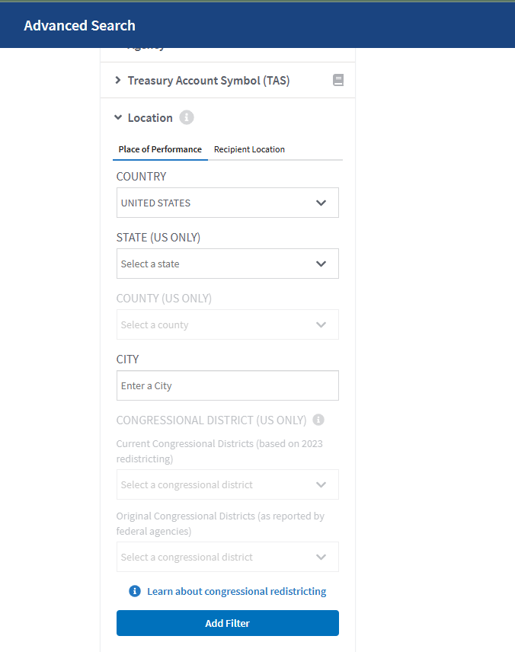

**NAICS and PSC Codes**

This step ensures that contracts matching either the specified NAICS codes or PSC codes in the market research request form. Follow these steps to download two separate datasets:

**Using NAICS codes:**

1. Go to the “North American Industry Classification System (NAICS)” filter.
2. Enter all the NAICS codes provided in the request form.

1. Download the data
   1. Once all filters are applied, click the “Submit” button either at the top or bottom of the filter panel.
   2. On the top right corner of the page, click “Download” > “Transactions” > “Everything.”
   3. A folder containing two datasets will be downloaded. The files will be named as follows:
      1. “Contracts_PrimeTransactions_...”
      2. “Contracts_Subawards_...”
   4. Open the folder and locate the “Contracts_PrimeTransactions_...” file. This is the file you need. Ignore the subawards file.
   5. Save this file as “NAICS_Data”

**PSC Codes (If any are specified in the market research request form):**

1. Clear the NAICS code filter.
2. Locate the “Product Service Codes (PSC)” filter.
3. Enter all the PSC codes from the request form.

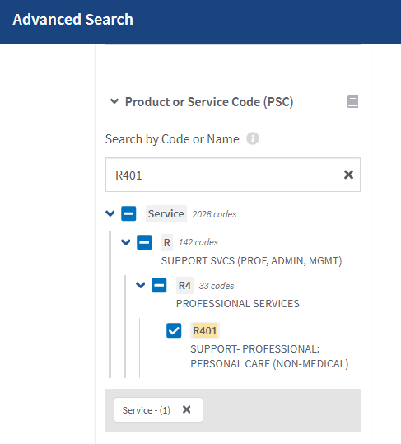

1. Download the data:
   1. Repeat the download steps:
   2. Click “Submit” to apply the filters.
   3. Select “Download” > “Transactions” > “Everything.”
   4. From the downloaded folder, find the “Contracts_PrimeTransactions_...” file.
   5. Save the file as “PSC_Data.”

**Step 2: Using the APEX Market Research App to Generate Analysis Results**

By the end of the previous step, you should have two Excel files “NAICS_Data” and “PSC_Data.” Now, go to the “APEX Market Research App” at <https://galsaifi-apex-market-research-app-market-research-app-1nl6gw.streamlit.app/>

**Data Upload: NAICS Data (Required)**

1. Find the NAICS Upload Section
   1. Under the “NAICS Code Dataset” section on the left side of the app, you’ll see an upload box.
   2. Drag and drop the “NAICS_Data” file into the upload box or click the “Browse files” button to locate and upload the file from your computer.
2. Once the file is uploaded, a message will appear indicating whether the file was successfully uploaded.
3. Below the upload box, the app will extract and display the NAICS codes from the uploaded dataset.
   1. Verify: Check the displayed NAICS codes to confirm they match the ones from your dataset.

**Data Upload: PSC Data (Optional)**

1. Find the PSC Upload Section
   1. Under the “PSC Code Dataset” section on the right side of the app, you’ll see an upload box.
2. Drag and drop the “PSC_Data” file into the upload box, or click the “Browse files” button to locate and upload the file from your computer.
3. Once the file is uploaded, a message will appear indicating whether the file was successfully uploaded.
4. Below the upload box, the app will extract and display the PSC codes from the uploaded dataset.
   1. Verify: Check the displayed PSC codes to confirm they match the ones from your dataset.

**Keywords (Optional)**

If the NAICS codes in your dataset are too broad or generic, you can specify certain keywords for additional filtering. Follow these steps:

1. Find the “Enter Keywords (Optional)” section on the dashboard.
2. In the input box labeled “Enter Keywords (comma-separated):”, type all relevant keywords, separating them with commas.
3. Once all keywords are entered, hold Ctrl and press Enter on your keyboard to populate the keywords.
4. Check the “Entered Keywords” list below the input box to confirm that all keywords were entered correctly.

**Click the “Generate Results” button at the bottom of the page.**